

Riverside Primary School & Nursery
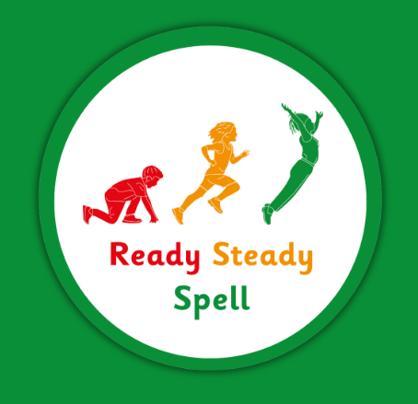
Spelling Policy

Intent
At Riverside Primary School and Nursery, we believe that all our children can become fluent, confident and competent spellers. We encourage our pupils to think and write creatively, be adventurous with their use of language and to write with clear purpose and for pleasure. In order for these aims to be realised, it is essential that our pupils learn the knowledge and skills to spell accurately. We want our pupils to be equipped with the knowledge and range of strategies for learning spelling and to be able to apply their strategies when spelling words in their writing.
To ensure this happens we teach using Ready Steady Spell. This is a systematic spelling programme which covers all the National Curriculum objectives in a cyclical way.
The progression document systematically develops children’s understanding of morphological and phonological spelling knowledge and rules, as appropriate, and builds upon previous learning in an incremental manner as they move through school. Children are also taught a range of engaging and interactive strategies which can be used to support recall of spellings and moving spellings into the Long Term Working Memory. Ready Steady Spell also supports transition into Y6 through the use of spelling journals, children identifying their own misspelling and the teaching of editing skills etc in Year 6 term 2.
We have a skilled English Leader in our school who is responsible for Ready Steady Spell, monitoring and supporting the practice and ensuring the high quality teaching of the programme.

Implementation
Year 2
Daily Lessons

- Spelling is taught daily, for 20 mins. We begin this the first week of term.
- Built into the programme is a review session every Friday, alongside regular review and assessment weeks, so that we have a clear understanding of where our children are at and what further teaching they may need to allow them early success.
- The daily sessions include a clear 4 part lesson, Revisit/Revise, Teach, Practice and Apply and cover Common Exception Words (CEWs), strategies to support remembering the spellings, teaching of rules where appropriate and application into writing.
- We follow the Ready Steady Spell progression document through Year 2 which covers all the National Curriculum (2014) expectations and clearly sets out what is to be taught and when.
- The objectives are returned to within and across the year group three times to ensure that spellings are embedded.
- We have a weekly spelling test. This is in addition to the lesson. The spellings are set out within the programme and are based upon what has already been taught and CEWs for the week. Children will not be asked to spell words they have not previously been taught and exposed to.
- We send home parent sheets weekly which provide the words for the spelling tests and the strategies that have been suggested to support their learning. These will be discussed, explained and shared with parents so that home school links can be developed and so that parents are clear on the best ways to support their child(ren) in embedding spellings.

Years 3-6
Lessons 3x per week

- Spelling is taught 3 times per week. This begins in the first week of the Autumn term.
- Built into the programme is a review session every Friday, alongside regular review and assessment weeks, so that we have a clear understanding of where our children are at and what further teaching they may need to allow them early success.
- The daily sessions include a clear 4 part lesson, Revisit/Revise, Teach, Practice and Apply and cover Statutory Word List words, strategies to support remembering the spellings, teaching of rules where appropriate and application into writing.
- In Summer 2 for Year 4, and Spring 1 and 2 and Summer 1 terms for Year 6, revision weeks are built into Ready Steady Spell which link directly to the end of KS2 content domains.
- In Year 6 Summer 2 term Ready Steady Spell provides support for transition and children identifying their own misspellings, using spelling journals, editing writing etc.
- We follow the Ready Steady Spell progression document through Years 3 - 6 which covers all the National Curriculum (2014) expectations and clearly sets out what is to be taught and when.
- The objectives are returned to within and across year group three times to ensure that spellings are embedded
- We have a weekly spelling test at the end of each week. This is in addition to the lesson. The spellings are set out within the programme and are based upon what has already been taught and Statutory Word List Words for the week. Children will not be asked to spell words they have not previously been taught and exposed to.
- We send home parent sheets weekly which provide the words for the spelling tests and the strategies that have been suggested to support their learning. These will be discussed, explained and shared with parents so that home school links can be developed and so that parents are clear on the best ways to support their child(ren) in embedding spellings.

Additional Support
Ready Steady Spell: Go
- Any child who is identified as requiring additional support will receive immediate intervention through the Ready Steady Spell: Go sessions. These are in addition to their Ready Steady Spell lesson.
- The sessions are 15 mins long and the frequency is assessed on needs by the class teacher.
- The sessions use the same procedures, resources and materials as Ready Steady Spell but with more repetition and scaffolding with a fully trained adult.
- Children with common and specific difficulties are taught in small groups/1:1 using the Ready Steady Spell: Go materials.

Impact
Assessment
Formative
- Daily formative assessment is built into the Ready Steady Spell teaching sequence and the workbooks have a dedicated, daily opportunity to record formative assessment to be reinforced in the Ready Steady Spell: Go sessions
- The weekly Friday session allow opportunities to review and identify gaps in learning that will then be addressed in the Ready Steady Spell: Go additional sessions
- Ongoing observations of children during the spelling lesson to inform gaps in learning and broader application of skills and knowledge across the curriculum
Summative
- Regular five or six weekly assessments take place as identified in the Ready Steady Spell progression document. These weeks will be used to assess progress and identify children who need further group/individual support.
- The assessments will be shared with the English Leader to narrow attainment gaps between different groups of children, with a focus on the bottom 20%

